# Measuring and modeling the marine photodegradation of HPAM using accelerated weathering and light scattering size exclusion chromatography

Eystein Opsahla,b, Aksel Hiorthaand Roald Kommedal*b

a [Eysteino@hotmail.com](mailto:Eysteino@hotmail.com) National IOR centre, University of Stavanger, Kjell Arholms gate 41, 4021 Stavanger, Norway  
b [Roald.Kommedal@uis.no](mailto:Roald.Kommedal@uis.no) Institute of chemical, biological, and environmental sciences, University of Stavanger, Kjell Arholms gate 41, 4021 Stavanger, Norway  
*Corresponding author

## Keywords

* Accelerated weathering
* EOR
* Ultimate marine fate
* Light scattering
* Depolymerization
* Size exclusion chromatography
* HPAM
* Marine lifetime

## Highlights

* A simple marine depolymerization model for HPAMs is developed
* Marine lifetime is highly dependent on environmental and structural variables
* Sunlight is able to degrade some HPAMs within a moderate amount of time
* Depolymerization follow random binary chain scission kinetics
* Photocatalytic production of oxygen radicals is responsible for degradation

## Abbreviations

P(AM), Poly(acrylamide)  
P(AC), Poly(acrylate)

HPAM, Partly hydrolyzed polyacrylamide, AM/AC copolymer

P(AMPS), poly(2-acrylamideo-2-methylpropanesulphonic acid)

EOR, Enahnced oil recovery

*Mw,* weight average molecular weight

*Mn,* number average molecular weight

*MW*, nominal molecular weight, moment not specified

kDa, kiloDalton or kg mol-1

MDa, megaDalton or Mg mol-1

*R,* depolymerization rate, number of chain scission events per unit volume per unit time

*RC*,depolymerization rate for specified concentration

*R0*, normalized depolymerization rate for *C* = 1 g L-1

*ΔMw*, apparent depolymerization, reduction in *Mw* as measured by light scattering

*Δ*[*C*], absolute depolymerization, increase in number of particles following depolymerization

*C*, Polymer mass concentration [g L-1]

[*C*], molar particle concentration (from C and *Mw)*

# Abstract

Polymer flooding rely on heavy use of synthetic polymer for enhancing oil recovery (EOR) rates and is currently undergoing feasibility studies for implementation on the Norwegian continental shelf. The use of such polymers are at the same time becoming increasingly controversial and several aspects related to the back-production and discharge of polymer, and subsequent marine fate and effects, remains unclear, and models for prediction across the countless number of possible molecular configurations are lacking. Here, partly hydrolyzed polyacrylamides (HPAM) and associated homopolymers are exposed to North Sea like marine conditions using an accelerated weathering device. The decrease in weight average molecular weight (*Mw*) is monitored with multi angle laser light scattering size exclusion chromatography. Effects on depolymerization rates from polymer composition, concentration, *Mw*, and additives associated with photocatalysis and oxygen radical chemistry are explored. Depolymerization appear to follow random binary chain scission kinetics mediated through photocatalysis of deleterious radicals that are strongly amplified by EDTA-iron(III) complex and inhibited by thiourea. The components of ordinary seawater accelerate depolymerization considerably relative to deionized water. Hypoxic conditions and the presence of non-complexed iron(III) has little effect. Depolymerization rates depend strongly on concentration but not *Mw.* Apparent depolymerization increases with initial *Mw* however. Susceptibility ranks PAC >> HPAM > PAM > PAMPS. A simplistic marine photocatalytic depolymerization model was devised to make crude estimates on marine lifetime, at which point biodegradation should lead to a rapid decline of residual polymer. A sizeable discharge of HPAM (30 % hydrolyzed) with initial *Mw* of 10 000 kDa to the middle of the North Sea returns a lifetime of 3 615 days using this model. However, a moderately low *Mw (10-100 kDa)* is reached long before biomineralization becomes likely, happening as soon as a few months post-discharge. This in the meantime dictate behavior with respect to the number of particles, solubility, transport mechanisms, and potentially adverse effects in the marine ecosystem. More advanced models need apply to exploit these data to its full potential.

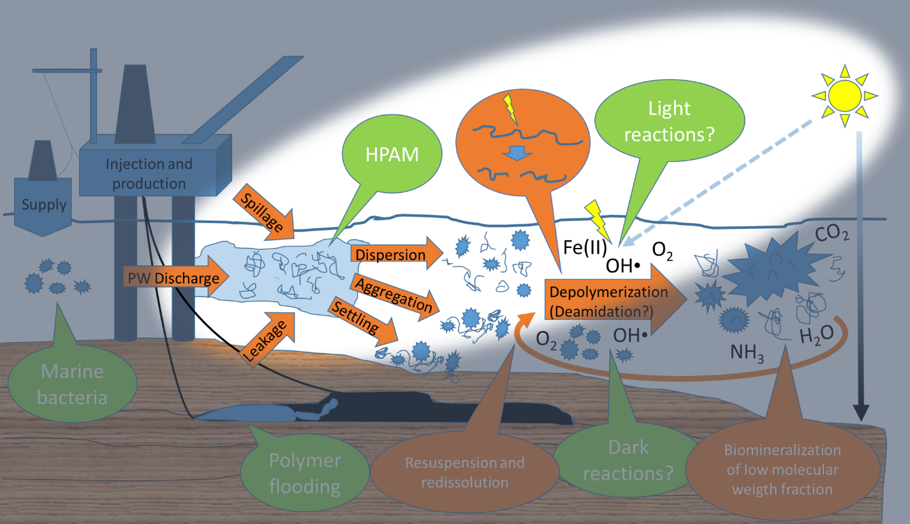

# Introduction

Polymer flooding may increase oil recovery rates by several percent with modest effort and shows promise for the aging fields on the Norwegian continental shelf (Smalley et al., 2018). It does however require large quantities of polymer which runs the risk of being released to the natural environment through either back-production with subsequent discharge of produced water or spills (Boysen et al., 2013; Manichand et al., 2013; Najamudin et al., 2014; Standnes and Skjevrak, 2014; Statoil, 2017).

Variations of linear partially hydrolyzed polyacrylamides (HPAM) in the MDa range are preferred. Besides acrylic acid (AC) and acrylamide (AM), other moieties like 2-acrylamide-2-methylpropanesulphonic acid (AMPS), are often included to add functionality or improve chemical stability (Thomas et al., 2012; Wever et al., 2011).

While nanomaterials in the environment has attracted much interest over the last decades (Farré et al., 2009; Howard, 2010), water soluble synthetic polymers have recently begun to attract attention as a potentially overlooked class of pollutant in natural waters (Huppertsberg et al., 2020). At regulator level this is reflected by the Norwegian environment agency’s call for more knowledge to make well-informed decisions about polymer flooding (Olje-og energidepartementet, 2018; Spildo et al., 2012) also requested by the British (Oil and Gas Authority, 2017). Nonetheless, the practice continue in other jurisdictions while similar polymers are enjoying widespread use in other industries, although not without controversy (Guezennec et al., 2014; Standnes and Skjevrak, 2014; Xiong et al., 2018).

Key environmental risk parameters, such as longevity, ecological impact, and ultimate environmental fate, are necessary for sound environmental management. Not only for the diverse range of polymer configurations in original products (Gaillard et al., 2010; Wever et al., 2011), but also for the countless number of possible degradation intermediates (Dale et al., 2015). To the best of our knowledge, little explicit data, let alone good models, exist for predicting this in marine settings (Guezennec et al., 2014; Nyyssölä and Ahlgren, 2019; Xiong et al., 2018).

Depolymerization, i.e. scission of the polymers backbone, is known to occur as a result of exposure to various physical and chemical degrading factors, in particular free radicals and ultraviolet radiation (Caulfield et al., 2002; Gaillard et al., 2010; Seright and Skjevrak, 2015). Even though direct photolysis is unlikely for materials with little overlap between incident light and its absorption spectrum, indirect degradation trough photocatalysed production of oxygen radicals is significant (Yousif and Haddad, 2013). Such processes are well described and has been exploited for treating HPAM containing effluents in photochemical advanced oxidation processes (El-Mamouni et al., 2002; Kaczmarek et al., 1998; Lu et al., 2012; Wang et al., 2006). In natural systems, sunlight possess the necessary energy to weather most materials and is through this mechanism a driving force for degradation of non-biodegradable materials in the ocean (Fan, 2008; Rose, 2012; Zafiriou et al., 1984).

We did not succeed in identifying any previous experimental work on the effects of sunlight on marine depolymerization rates which ultimately holds the key for prediction, or more importantly, for conducting scenario-based marine distribution, fate, and impact modeling (Dale et al., 2015). Research seems to be have been kept back by limitations to analytical polymer chemistry (Howard, 2010; Huppertsberg et al., 2020). In fact, only one relevant study could be found, where based on the production of •OH in natural waters, Nomi et al. guesstimated estimated marine half-life to be 14.6 years for PAM at 1 mg L-1 (Nomi et al., 2015). However, advances in light scattering size exclusion chromatography has made it a conceivable task to characterize a wide range of polymers with enough accuracy for this to be examined in detail (Andersson et al., 2003; Podzimek, 2019, 2011).

HER BØR VI HA EN EKSPLISITT MÅLFORMULERING AV TYPEN: « In this work we present photodegradation results of HPAM in simulated North Sea epipelagic marine waters including degradation intermediates and….»

# Materials and methods

## Test compounds

Polymers were acquired from Polysciences (Polysciences Europe GmbH, Germany) including the homopolymer polyacrylic acid (PAC) with nominal molar masses (MW) 2 kDa, 50 kDa, 450 kDa, and polyacrylamide (PAM) 10 kDa, 600 kDa, 6 MDa, and HPAM copolymers (acrylamide/acrylic acid ) 9010 200 kDa, 3070 200 kDa, 7030 18 MDa, and 6040 10 MDa. Poly-2-acrylamido-2-methyl-1-propanesulfonic acid (PAMPS) 2 MDa was acquired from Sigma-Aldrich® (Merck Life Science AS, Norway)

## Test methodology

Polymer is exposed to conditions mimicking the epipelagic North Sea. Three separate medium-term experiments were conducted to explore how marine depolymerization relate to polymer structure, concentration, molecular weight, and oxygen radical chemistry (ROS). In the first experiment we studied the …. Osv. The “structure” experiment exposes every polymer at 40 mg L-1. The “ROS” and “concentration” experiments exposed PAM 6 MDa to various agents associated with (photo)radical chemistry or from dilute (0.1 mg L-1) to concentrated (10 g L-1) regimes respectively. An accelerated weathering device fitted with a 1500 W xenon arc lamp and “Daylight reduced IR” filter was used for generating artificial sunlight corresponding to the solar spectrum at sea level (Atlas Suntest CPS+, Cromocol Scandinavia AB, Sweden). Irradiance in the near UV (300-400 nm) was set to 40 W m-2 resembling a clear summers day in the Nordic lattitudes. Albeit, 12 hours per day photoperiods yields a more tropical exposure rate of 1728 kJ m-2 day-1 (Bird and Riordan, 1986). Proper cooling is required to replicate the annual temperature range of the North Sea in a Suntest setup (Janssen et al., 1999). The device was therefore fitted with a coolant-loop fed radiator over the air intake in addition to placement in a refrigerated room. Seawater (Salinity 34.8 ‰) was collected through a subsea intake in Byfjorden outside of Stavanger, Norway (75 m below MSL, 59.03°N, 5.62°E), nano-filtrated upon arrival in the lab (PLCXK 1000 kDa MWCO membrane, Cogent M1 TFF system, Merck Millipore®), and kept sterile until use with UVC (Solaris[PRO], WYATT technology Europe GmbH). Sodium azide (0.1 g L-1, 99 %, Thermo Fisher Kandel GmbH) was added and polymer dissolved by shaking over several days to make high concentration stocks (≈10 g L-1), either in deionized (PURELAB® Flex II, Elga Labwater Ltd.) or seawater depending on experiment. Additional stocks were prepared directly in mobile phase for chromatographic characterization of polymer under ideal conditions. Acidic polymers were neutralized by careful addition of sodium hydroxide (2.5 M, EMSURE®). PAM 6 MDa working stocks were prepared for the “concentration” and “ROS” experiment whose additives, Iron(III)chloride (>98 %, Merck-Schuchardt OHG), Thiourea (99 % ACS reagent, Sigma-Aldrich®), and EDTA (tetra-sodium salt hydrate, ≥97 Sigma-Aldrich®) were prepared separately in high concentration stocks to be added immediately before exposure. Polymer was diluted to target concentrations and shaken until visible gel disappeared before transfer to dark control (50 mL Falcon tubes, BD Plastipak) and exposure containers (50 mL UV-transparent fused quartz flasks, Quartz scientific, Inc). The flasks were capped with rubber stoppers penetrated by syringe needles (0.8x50 mm) with PTFE filters (0.45 µm, Ø 4 mm, Chromacol LTD) to allow some atmospheric exchange while preventing evaporation (*Pic. 1.a*). Nitrogen (4.0, Praxair Norge AS) was used for purging media for 10 minutes for hypoxic testing before capping with airtight rubber stoppers (*Pic. 1.b*). Dark controls were kept in the same room, no mixing or shaking was applied during exposure, and when irradiated, the media was measured to average 3.0 °C above the logged chamber temperature.

## Sample preparation

Sample extraction and preparation was carried out in a laminar flow hood to avoid particulate contamination. Samples were drawn at specified intervals, either directly from stock solutions, exposure media and dark controls, or indirectly via analyte-enriched media. Enrichment was needed where polymer concentrations (or *Mw*) are too low for direct measurement and achieved by dialyzing the contents of a flask against deionized water to constant conductivity (SnakeSkin™ 3.5 kDa MWCO, Thermo Scientific™), before evaporation (40 °C, 2.3 kPa, Multivapor™ P-12, BÜCHI Labortechnik AG) until only a few milliliters, or a viscous residue. Sodium azide (0.1 g L-1) was used for preservation before filtration with appropriately sized syringe filters, 0.45 µm (< 1 MDa, CHROMAFIL® GF/PET no. 729033) or 1.2 µm (> 1 MDa Whatman® GD/X no. 6886).

***a)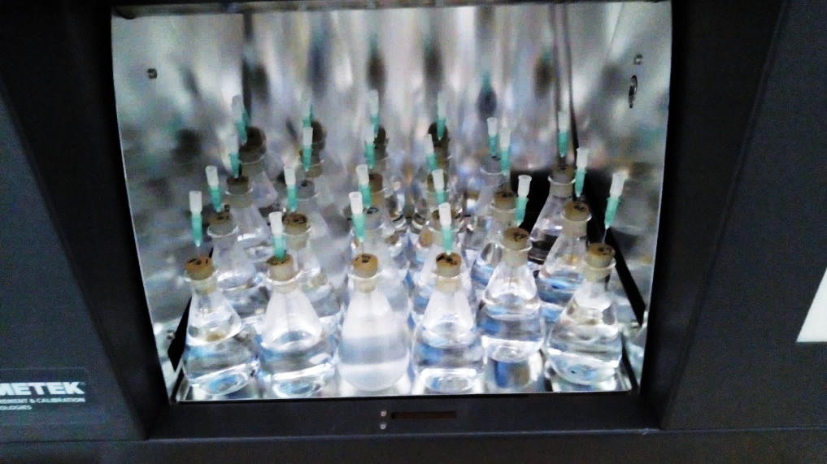b)***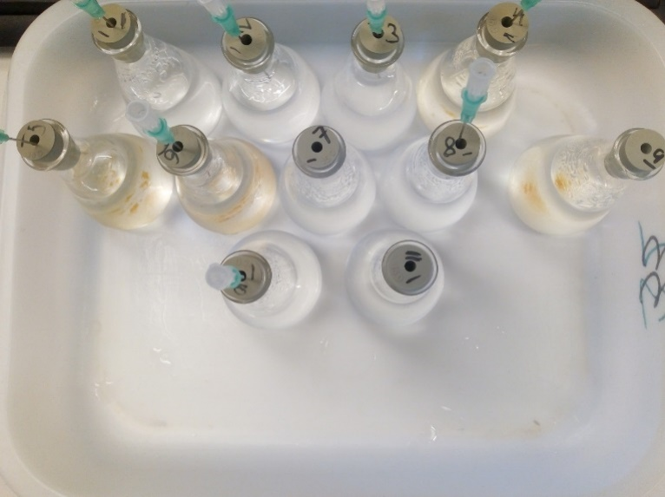

*Picture 1 Experimental setup* ***a)*** *Exposure chamber with test flasks from the “structure experiment” immediately before exposure. Note the cloudiness of the flasks in the 2nd and 3rd columns from left which contain PAC. This cleared with exposure, the polymers apparently re-dissolving with depolymerization* ***b)*** *Test flasks from the “ROS experiment”. Hypoxic tests are performed sealed flasks. Note the iron(III) precipitate, polymer remained dissolved in spite of this.*

## Characterization

Weight average molecular weight (*Mw*), molar mass distribution, and polymer mass concentration (*C*) was determined using a HPLC (1260 infinity, Agilent technologies Inc.) connected to an 8 angle light scattering detector (DAWN® HELEOS® II, WYATT Technology Europe) and a differential refractive index detector (Optilab® T-rEX™, WYATT Technology Europe). SEC-columns Shodex OHpak SG-B, SB-803 HQ, SB-807 HQ, LB-806M (300x8.0 mm, Showa Denko K.K) and PL aquagel-OH MIXED-M (300x7.5 mm, Agilent technologies Inc.) are employed in various configurations under ambient conditions. The preferred configuration is serial coupled SG-B, LB-806M, and PL aquagel-OH MIXED-M due to its versatility. A 100 μL injection loop was used and the amount of sample injected tuned from 10 μL to 100 μL depending on sample concentration. An in-line degasser and 0.1 µm filter was used, and the columns and mobile phase was polished by re-circulation for a few days before analysis. The system was additionally flushed with 100 mL (xx retention times) mobile phase between every injection to further suppress light scattering (LS) noise and dRI baseline fluctuations by carry-over. For similar reasons, mobile phase was prepared in large batches (5 L) and filtered similar to the seawater, comprising 12 g L-1 HEPES-Na (2-[4-(2-Hydroxyethyl)-1-piperazinyl]-ethanesulphonic acid sodium salt, ≥99.5%, VWR BDH chemicals), 8 g L-1 sodium nitrate (EMPLURA®), 0.8 g L-1 nitric acid (Suprapur®), and 0.1 g L-1 sodium azide in deionized water. Defouling of the LS-detector was realized by ultrasonication (COMET, WYATT technology Europe) for 30 minutes between every run. More elaborate defouling was needed intermittently and achieved by overnight restoration with 20 % nitric acid followed by treatment with 2% Hellmanex™ III (VWR International AS, Norway). Bovine serum albumin (BSA >97 %, Sigma-Aldrich®) was used for LS-detector renormalization. Elution rate was adjusted between 0.15 mL min-1 (> 1 MDa) and 1 mL min-1 (< 100 kDa) to ensure optimal balance between retention, in-column shear degradation, and signal to noise ratios (Barth and Jr, 1984; Podzimek, 2011). Data was collected and analyzed using ASTRA 5.0 (Wyatt Technology Corporation). Having negligible importance in comparative studies, *dn/dc* was set 0.165 mL g-1 to simplify analysis, apart from BSA (0.185 mL g-1). Correspondingly, the 2nd virial coefficient (*A2*) is ignored. “Random coil” and “Berry” are preferred formalisms for estimating *Mw,* in general applying a 1st order fit for < 100 kDa polymers and 3rd with > 1 MDa polymers unless “random coil” is applicable (Example in *fig. 1*), all according to literature recommendations (Andersson et al., 2003; Podzimek, 2014). Runs with more than 5 % uncertainty according to ASTRA 5.0 algorithms are rejected.

**a)**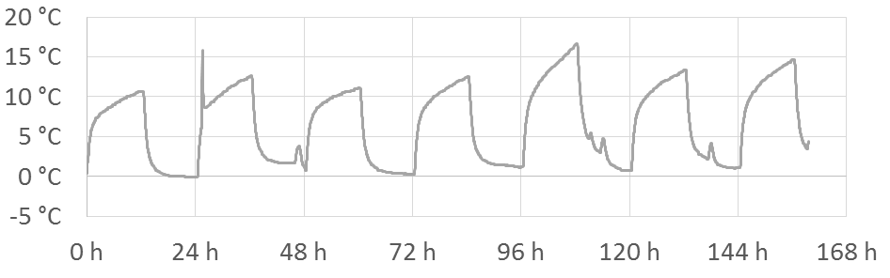

**b)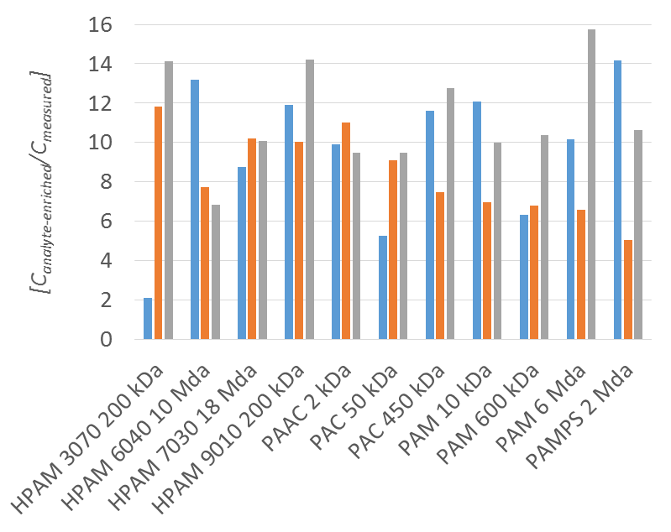c)**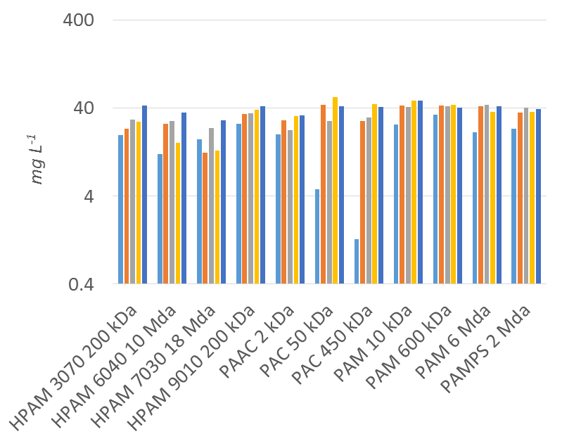

Figure 1 Structure experiment **a)** Exposure chamber temperature from the first seven days of the experiment **b)** From left to right, analyte-enrichment ratios [Canalyte-enriched/Cmeasured] before, after 30 days, and after 60 days of exposure. Average analyte-enrichment ratio (± SEM) is 9.8 ± 0.5. **c)** From left to right, recovery of dissolved polymer from seawater before, after 30 days, after 60 days of exposure, and nominal values derived from the concentration of polymer measured in stocks or weighed amount of polymer. Averages are [mg L-1 ± s.d] 18.4 ± 9.1, 32.6 ± 9.4, 32.7 ± 7.2, 35.5 ± 12.0 and 39.7 ± 5.0 respectively. Note the low initial but increasing recovery of PAC 50 and 450 kDa due to extensive precipitation. The variable recovery of high Mw HPAM results from sometimes exceedingly high viscosity. The low recovery of low Mw fractions in PAC 2 kDa and PAC 50 kDa results from overlapping solvents peaks in chromatography, and probably because of some loss from dialysis.

**a)****b)**

Figure 2 HPAM 9010 200 kDa tested at 40 mg L-1, isolated from seawater and characterized after analyte-enrichment using OHpak SB-G, LB-806M, PL-Aquagel OH Mixed-M @ 1 mL min-1. The three curves represent polymer at: 1. Before exposure (injected mass 30.57 µg, random coil fit, detector 1 disabled) 2. After 30 days (injected mass 34.29 µg, Berry 2nd degree fit, all detectors enabled) 3. After 60 days (injected mass 49.64 µg, Berry 1st degree fit, detector 1 disabled) **a)** Chromatograms, differential refractive index signal (normalized) vs elution volume, diagonal lines represent molar mass **b)** Cumulative molar mass (Mw) distribution curves.

# Results and discussion

## Part 1 - Experimental

Average daily low/high chamber temperatures was 1.2-14.7 °C, 0.9-16.8 °C, and 1.6-16.4 °C in the “Structure”, “ROS”, and “Concentration” experiment respectively. Variations besides diurnal are caused by seasonal changes and activities in the lab (example *fig. 1.a*, logs in supplementary data). Correspondingly, total radiant exposure *(He)* in each of the experiments was 103.7, 51.8 and 34.6 MJ m-2 (300-400 nm) as measured by the built in photodetector. Recovery of polymer reflected target concentrations with some exceptions. Analyte-enrichment, ultimately permitting detailed characterization of polymer between 0.4-4 000 mg L-1 and 1.5-10 000 kDa (*table 1*), averaged 9.8 [*Canalyte-enriched/Cmeasured*] in the “structure” experiment, albeit with quite high variability (*fig. 1.b*). A higher average (17.7) was attained in the “Concentration” experiment. The results from characterization presented in *table 1* are derived from the most representative SEC-MALLS-dRI runs selected from the 456 in total needed for optimizing run parameters and achieving desired quality where much care has been put into ensuring consistent interpretation and representation (See example in *fig.2*.*a-b* and supplementary material). In all experiments, *Mw* decrease dramatically with exposure. Apparent depolymerization, or rather the absolute decrease in *Mw* (*ΔMw)*,is clearly linked to polymer concentration, type of polymer, initial *Mw*, and is highly influenced by agents associated with photocatalysis. I.e. *ΔMw* decrease in magnitude with higher concentrations (Caruso et al., 2009; Gröllmann and Schnabel, 1982; Soponkanaporn and Gehr, 1988), lower initial *Mw* (Aarthi et al., 2007; Koda et al., 2011), in deionized water, and in the presence of radical scavenging thiourea (Prasad and Mishra, 2017; Seright and Skjevrak, 2015). *ΔMw* increase in magnitude with lower concentrations, higher initial *Mw*, in seawater relative to deionized water, and in the presence of photo-reactive iron(III)-EDTA complex (De Luca et al., 2014). It is mostly unaffected by hypoxic conditions and by the presence of non-complexed iron(III) (Kaczmarek et al., 1998; Seright and Skjevrak, 2015). The susceptibility towards depolymerization ranks PAC >> HPAM > PAM > PAMPS and the degree of hydrolysis (% carboxylate groups) increases susceptibility (Thomas et al., 2012; Vinu and Madras, 2008). Oxygen radical chemistry seems to be in agreement with existing literature on commercial EOR-polymers (Gaillard et al., 2010). The degree of hydrolysis also dictate solubility where initial precipitation is significant for PAC 50 kDa and PAC 450 kDa, both creating high turbidity solutions (*pic. 1.a*). HPAM 3070 200 kDa was less turbid and precipitation ostensibly less severe (*fig. 2.c*). Test solutions eventually cleared and recovery of dissolved polymer improved with depolymerization, even though PAC 2 kDa and PAC 50 had seemingly less recovery in the end, but this was rather due to *Mw* being below the separation threshold in SEC. PAM 6 MDa at 10 g L-1 also gave a turbid solution, but unlike the above, recovery of polymer from seawater was as expected from the nominal concentrations. Slow dissolution kinetics together with at times high viscosity, which is particularly important for high MW polymers, is probably to blame for the variable recovery of HPAM 6040 10 MDa and 7030 18 MDa considering that there was no mixing after the initial preparation (Miller-Chou and Koenig, 2003). Where recovery is low, the reported *Mw* is biased and for this reason marked with an asterisk in *table 1* and excluded from post hoc analysis. On the other hand, these measurements indicate the *Mw* at which solubility decreases the most, which seems to be above roughly 20 kDa for pure PAC and somewhat higher in HPAM 3070 (See chromatograms in supplementary material). Depolymerization was nevertheless confirmed, demonstrating that depolymerization can and does happen to polymer in a precipitated state, eventually resulting in re-dissolution even without mixing. In less hydrolyzed polymer, e.g. HPAM 6040 10 MDa, low initial recovery was unproblematic since the chromatograms appear rather unchanged between polymer recovered from seawater and stock solutions. In the end, ultimate recovery of polymer was high altogether (*fig. 2.c*). As laid out in the second part of this paper, these data permit estimation of depolymerization rates and prediction of environmental lifetime as a function of initial *Mw*, concentration, and type of polymer. Lifetime corresponding to the number of days needed to degrade the polymer to a point where biodegradation becomes feasible, i.e. 0.7 kDa (*Mw*) (El-Mamouni et al., 2002; Nyyssölä and Ahlgren, 2019; Wennberg and Petersen, 2017). Estimated depolymerization rates and corresponding lifetimes for experimental conditions are shown in *table 1*.

Table 1 Characterization summary table. Concentration specific depolymerization rates Rc [nM day-1], normalized depolymerization rates R0 [nM day-1 @ 1 g L-1], and lifetimes [days to Mw = 0.7 kDa] are estimated from Mw0 [kDa] and C [mg L-1]using equations 6, 7, and 9 respectively. Resulting values vary in a linear dependent fashion on which measurements are used.

|  |  |  |  |  |  |  |  |  |  |  |  |  |  |  |
| --- | --- | --- | --- | --- | --- | --- | --- | --- | --- | --- | --- | --- | --- | --- |
| **Experiment**  Sample  Nominal MW | **Polymer concentration**  **[mg L-1]** | | | | **Mw [kDa]**  **(after x days)** | | | | | | | **Depolymerization (From Ctarget and Mw0)** | | |
| ***Cmeasured***  ***[Average]*** | ***Cnominal*** | ***Ctarget*** | ***Stock*** | | ***Dark control*** | **0** | **10** | **20** | **30** | **60** | ***RC* [nM d-1]** | ***R0* [nM d-1]**  **(*RC* @1 g L-1)** | **Lifetime [days]**  **(@*Ctarget*)** |
| **Structure** |  |  |  |  | |  |  |  |  |  |  |  |  |  |
| HPAM 3070 200 kDa | 25.7 | 42.8 | 40 | 494 | | ***28\**** | ***34\**** | - | - | **28** | **8.2** | 80 | 894 | 713 |
| HPAM 6040 10 MDa | 21.9 | 35.6 | 40 | *5955\** | | ***2585*** | ***7416¨*** | - | - | **54** | **25** | 27 | 297 | 2138 |
| HPAM 7030 18 MDa | 16.9 | 29.2 | 40 | *6630\** | | ***2941*** | **10123¨** | - | - | ***64*** | **21** | 31 | 351 | 1820 |
| HPAM 9010 200 kDa | 33.9 | 42.0 | 40 | 480 | | **479** | **470** | - | - | **81** | **25** | 26 | 288 | 2215 |
| PAC 2 kDa | 25.7 | 32.9 | 40 | 2.6 | | **2.3** | **2.7** | - | - | **1.6** | **~~1.1~~** | 350 | 3909 | 119 |
| PAC 50 kDa | 32.7 | 42.5 | 40 | 115 | | ***35\**** | ***22\**** | - | - | **3.7** | **~~1.5~~** | 439 | 3899 | 162 |
| PAC 450 kDa | 26.4 | 41.4 | 40 | 1146 | | ***24\**** | ***18\**** | - | - | **6.3** | **2.3** | 289 | 3234 | 163 |
| PAM 10 kDa | 42.2 | 48.4 | 40 | 6.9 | | **7.6** | **8.2** | - | - | **7.1** | **~~4.9~~** | 25 | 282 | 2072 |
| PAM 600 kDa | 40.1 | 40.6 | 40 | 753 | | **698** | **837** | - | - | **70** | **29** | 22 | 245 | 2605 |
| PAM 6 MDa | 38.7 | 41.9 | 40 | 2661 | | **2202** | **3069** | - | - | **91** | **30** | 22 | 250 | 2554 |
| PAMPS 2 MDa | 34.9 | 39.3 | 40 | 993 | | **886** | **1161** | - | - | **245** | **96** | 6.3 | 71 | 8990 |
| **ROS (PAM 6 MDa)** |  |  |  |  | |  |  |  |  |  |  |  |  |  |
| Only polymer | 9095 | 9240 | 10000 | 3161 | | - | 2652 | 1 098 | 677 | 553 | - | 497 | 88 | 28861 |
| Only polymer | 859 | 924 | 1000 | 3161 | | - | 2547 | 498 | 262 | 195 | - | 161 | 161 | 8871 |
| Only polymer | 86 | 92.4 | 100 | 3161 | | 1973 | 2653 | 405 | 168 | 105 | - | 31 | 172 | 4669 |
| Fe(III) 5 mg L-1 | 83 | 92.4 | 100 | 3161 | | 2701 | 1884 | 344 | 156 | 101 | - | 32 | 180 | 4462 |
| Fe(III) 5 mg L-1 + Thiourea 50 mg L-1 | 85 | 92.4 | 100 | 3161 | | 2766 | 2650 | 663 | 414 | 254 | - | 12 | 68 | 11811 |
| Fe(III) 5 mg L-1 + EDTA 125 mg L-1 | 84 | 92.4 | 100 | 3161 | | 2516 | 2193 | 158 | 93 | 50 | - | 66 | 372 | 2159 |
| N2 Purge | 86 | 92.4 | 100 | 3161 | | 2002 | - | - | - | 108 | - | 30 | 168 | 4780 |
| Thiourea 50 mg L-1 | 90 | 92.4 | 100 | 3161 | | 2057 | 2549 | 974 | 508 | 394 | - | 7.4 | 42 | 19122 |
| Fe (III) 5 mg L-1 + N2 purge | 77 | 92.4 | 100 | 3161 | | 2511 | - | - | - | 86 | - | 38 | 213 | 3770 |
| Deionized water | 58 | 104.4 | 100 | 3161 | | *1770\** | *1503\** | *661* | 537 | 461 | - | 6.2 | 35 | 22947 |
| Deionized water + N2 purge | 67 | 104.4 | 100 | 3161 | | 1041* | - | - | - | 483 | - | 5.8 | 33 | 24338 |
| **Concentration (PAM 6 MDa)** |  |  |  |  | |  |  |  |  |  |  |  |  |  |
| Only polymer | 9256 | 9130 | 10000 | 3065 | | 2014 | 2771 | 798 | 568 | - | - | 718 | 128 | 19842 |
| Only polymer | 3528 | 3652 | 4000 | 3065 | | 2075 | 2537 | 573 | 370 | - | - | 475 | 168 | 12022 |
| Only polymer | 929 | 913 | 1000 | 3065 | | 2229 | 2641 | 363 | 224 | - | - | 207 | 207 | 6899 |
| Only polymer | 364 | 365 | 400 | 3065 | | 2290 | 2518 | 312 | 178 | - | - | 106 | 210 | 5408 |
| Only polymer | 89.1 | 91.3 | 100 | 3065 | | 2139 | 2306 | 221 | 133 | - | - | 36 | 203 | 3956 |
| Only polymer | 34.1 | 36.5 | 40 | 3065 | | 2024 | 2109 | 202 | 91 | - | - | 21 | 238 | 2684 |
| Only polymer | 8.59 | 9.13 | 10 | 3065 | | 2662 | 2536 | 186 | **81** | - | - | 6.0 | 191 | 2364 |
| Only polymer | 3.19 | 3.65 | 4 | 3065 | | 1941 | 3101 | ~~-~~ | **80** | - | - | 2.4 | 153 | 2347 |
| Only polymer | 1.00 | 0.91 | 1 | 3065 | | - | - | ~~-~~ | **62** | - | - | 0.8 | 141 | 1801 |
| Only polymer | 0.37 | 0.37 | 0.4 | 3065 | | - | - | ~~-~~ | **51** | - | - | 0.4 | 135 | 1496 |
| Only polymer | - | 0.09 | 0.1 | 3065 | | - | - | - | ~~-~~ | - | - | - | - | - |

*Poorly dissolved or precipitated polymer

¨Poor separation in SEC

**Bold**: Analyte-enriched media

*Italic underscore*: < 50 % recovery (*Cmeasured/Cnominal*)

~~Striketrough~~: Uncertainty too high or peak overlapping with solvent peak in SEC-MALLS-dRI

## Part 2 - Marine depolymerization modeling

It is thus been established that when discharged to marine systems, polymer may ultimately biodegrade when exposed to solar radiation in surface waters. But this still take several years to decades for more resilient polymers in spite of a high exposure rate, even when the polymer come severely pre-degraded. This can be attributed to the relatively high test concentrations. In a realistic scenario, concentrations are not going to stay in mg L-1 range for long and lifetimes should therefore become shorter according to our measurements. The exposure rate on the other hand should be lower due to a range of variables, effectively increasing lifetime. Marine fate, effects, and distribution models should compensate for these variables to render the experimental data useful for risk assessment. The depolymerization kinetics must be first be identified in order to achieve that. Mccoy and Madras described the nature of depolymerization and the effects of random binary chain scission on polymer characteristics (McCoy and Madras, 1997). Aarthi described how other modes of depolymerization would look like (Aarthi et al., 2007). Bellenger described how to predict polymer lifetime as a function of *Mn*, the number average molecular weight (Bellenger et al., 1995). Based on those works and the adapted model below, we see that random binary chain scission kinetics fits the observations. In constant polymer mass concentration *C* [g L-1] system, the number of chain scission events that any molecule experience on average *XHe* as a result of radiant exposure *He* [J m-2], relates to the number of molecules before [*C0*] and after exposure [*CHe*]:

 Eq.1 Chain scissions events per molecule

[*C*] is calculated from *C* and weight average molecular weight *Mw* [g mol-1] at desired time intervals, both obtained in SEC-MALLS-dRI:

 Eq.2 Molar concentration

The use of *Mn* is avoided as it introduces much uncertainty (see supplementary material, Podzimek, 2019). *XHe* calculated using *Mw* does not reflect the actual number of chain scissions in the same way as *Mn* would. However, it does not matter as long as polydispersity *Mw/Mn* stay unchanged which appears to be the case, it also approaches 2.0 which is an indicator for random binary chain scission (see supplemental data, McCoy and Madras, 1997). The radiant exposure *He* [J m-2] is the product of duration *Δt* [days] and irradiance *Ee* [W m-2], or as in this work, the exposure rate *De* [J m-2 day-1] with *Δt12+12* equaling the number of days with 12 hours of daylight and 12 hours of darkness:

 *Eq.3 Radiant exposure*

Given that *Δt* is known, a depolymerization rate *R(C,Ee)* [M-1 day-1] can be defined and interpreted as the number of chain scissions occurring per unit volume per unit time:

 Eq.4 Depolymerization rate

The 0th order rate law result when the above equations are merged to its simplest form:

 Eq.5 0th order rate equation

here used in its alternate forms for predicting *MwHe* in a constant *De* system where *R(C,De)* and initial conditions, *Mw0* and *C*,are known:

 Eq.6 Alternate form

and for estimating environmental lifetime considering that biodegradability is likely to increase substantially around some low *MwHe* cutoff, e.g. 0.7 kDa (Wennberg and Petersen, 2017; White et al., 2012):

 Eq.7 Lifetime prediction

*R(C,Ee)* or *R(C,De)*, hereafter referred to as *RC*, is dependent on *C* in addition to *Ee* or *De*, hence the notation, and is discussed later. Depolymerization proper *Δ*[*C*] takes place at a fixed rate according to this model. In the meantime, from the perspective of our experiments we see that apparent depolymerization (*ΔMw*) increases with the square of initial (*Mw0*)as explained in Figure 3. This means that the *Mw* of a 400 kDa polymer for example, will decline up to 16 times faster than a 100 kDa polymer until their *Mw* eventually converge. For any two polymers where *Mw0* is the only difference, the relationship is:

 Eq.8 ΔMw and Mw0

This implies that degrading polymer independent from *Mw0*, will reach a low *Mw* within in a relatively short time compared to the overall lifetime and soon become marginally different from polymer that has been discharged a long time ago. This is extremely important to have in mind for the environmental risk assessor since the properties of original product will disappear fast, giving the illusion that the polymer is degrading rapidly, while in reality it is not and is merely adding to the pool of existing pollution in another particle size range. The analog effect of which we have seen previously in municipal wastewaters (Ravndal et al., 2018). The “structure” experiment where various polymers with differing *Mw0* are tested at similar concentrations should tell whether this is true. We compute from the most representative metrics, i.e. what measurements are excluded, whether calculations are based on *C*target, *C*nominal, or *C*measured, and whether degradation is compared with dark controls, stocks, or seawater samples, that *RC* approximate 24nM d-1 (i.e. 10-9 M d-1) in PAM and moderately hydrolyzed HPAM, 397 nM d-1 in PAC, 56 nM d-1 in HPAM 3070 and 6 nM d-1 M inPAMPS. depending on. A good overlap between observation and prediction is revealed when plotting curves using the above rates with *Ctarget* and *Eq. 6* over the experimental data (Figure 4). Irregularities are primarily caused by non-consistent concentrations, and imprecisions concerning the measurement of polymer concentration and *Mw*, especially at low *Mw*. The model may therefore be used for forecasting *Mw* and predicting environmental lifetime with reasonable accuracy for such systems. PAM 6 MDa was selected for the follow up experiments from these measurements and because of its relative ease of handling and characterization, providing the best resolution overall. The model also fits “ROS” experimental data, where additives rather than polymer type influence depolymerization rates (Figure 5). Some deviations occurred for polymer in deionized water and with the addition of non-complexed Fe(III), both leading to low initial recovery of high *Mw* polymer, but yet again, recovery increased with time and depolymerization. Probable reasons are initial gelling with Fe(III) and deionized water being a worse solvent for characterization purposes than seawater. Anyhow, this suggest a common mode of degradation between all the experiments, i.e. random binary chain scission following photocatalysis of reactive oxygen species, and not direct photolysis (Vinu and Madras, 2008; Yousif and Haddad, 2013).

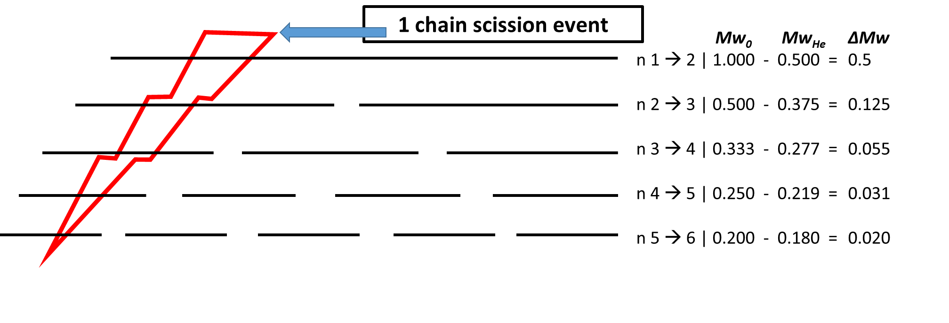

Figure 3 Consider the change in Mw (ΔMw) within the five monodisperse populations of equal mass resulting from one single chain scission event (midpoint). Mw0 is the initial weight average molecular weight (Mw), n is the number of molecules before and after chain scission, and MwHe is resultant Mw. The magnitude of ΔMw increase with the square of Mw0. E.g. (1/0.25)2 = 0.5/0.031 = 16 (from eq. 8).

**a)b) **

**c) d)** 

Figure 4 “Structure” experiment, depolymerization curves plotted over measurements using approximate Rc and target concentrations (40 mg L-1) **a)** PAM @ 24 nM d-1 , overlapping data from “concentration” experiment included for PAM 6 MDa **b)** Moderately hydrolyzed HPAM @ 24 nM d-1 **c)** PAC @ 397 nM d-1 **d)** PAMPS @ 5.7 nM d-1 and HPAM 3070 @ 56 nM d-1.

**a)b)** 

Figure 5 “ROS” experiment. Depolymerization curves plotted over measurements **Left:** PAM 6 MDa in seawater and deionized water (dH2O) with and without nitrogen purge (±O2) **Right:** Depolymerization of PAM 6 MDa in seawater spiked with 5 mg L-1 iron(III) (5 mg L-1 ) With or without nitrogen purge (-O2), thiuorea (50 mg L-1) and EDTA (125 mg L-1).

Polymer concentration also has to be compensated for in order to make real world predictions where concentrations inevitably vary and are generally much lower than in experimental settings. As previously stated, there is a clear link between *ΔMw* and *C* in the “concentration” experiment where the only variable is polymer concentration (Table 1 and *fig 6.a-b*)*.* When the respective *Rc* are plotted against *C* (*fig. 6.d*), power regression (Weighted R2 = 0.99) reveal a fractional exponential relationship:

 Eq.9 Concentration dependency

where *R0* [nM d-1] equates to *Rc* @ 1 g L-1. By inserting *Eq.9* into *Eq. 6* we get to make a regularized fit that need only one single input value to approximate the data (e.g. 162.5 nM d-1, Figure 6.c). However, *Mw* and therefore *Rc,* are less reliable when measured in the extreme domains of concentration and *Mw* which introduces a slight curvature. At low concentrations and low *Mw*, departures originate from overestimated *Mw* due to excessive light scattering noise. With high concentrations, where also *A2* become important, comes a tendency to saturate columns and even detectors leading to worse measurements and systematic underestimation of *Mw* (Podzimek, 2011). It is better to ignore the curvature and use *R0* obtained from the sweet spot of concentration in place of the average obtained from regression. Ultimately, this allow prediction of *Mw* and lifetime in variable concentration systems, and importantly, extrapolation to lower and more environmentally relevant concentrations. An added benefit is that *R0* permits straightforward comparison of depolymerization rates between polymers tested at different concentrations as shown in table 1. In practical EOR, degree of co- or ter-polymerization is tailored to fit reservoir characteristics and are usually synthetized from acrylamide, acrylic acid, and 2-acrylamido-2-methylpropanesulphonic acid (Thomas et al., 2012; Wever et al., 2011). Amide functional groups also tend to hydrolyze, increasing acrylic acid content as the polymer age. This can happen both within the reservoir, during production, or post discharge (Godwin Uranta et al., 2018; Joshi and Abed, 2017). Unfortunately, the widely used DREAM model does not yet accept input in this format (Rye et al., 2014). We therefore build further upon the model in this work to handle variable polymer structure, which is also the reason why a wide range of polymers are tested. A linear relationship between depolymerization rate and degree of hydrolysis could be assumed since copolymerization is statistical. However, this will be misleading for moderately hydrolyzed HPAM as they appear to be as durable as pure PAM. Only at 70 % hydrolysis does the depolymerization rate depart significantly. Regardless, the rates at which PAM degrade relative to PAC are similar to observations made previously (Vinu and Madras, 2008). For PAMPS, there is no choice but to assume a linear relationship since no AM-AMPS copolymers are tested. However, the difference in chemical resilience between PAM and PAMPS is much lower than PAM and PAC and errors therefore having less impact on outcome. It becomes easier to grasp the inflection point where terpolymers should begin to degrade noticeably faster by using a surface plot in the form of:

 *Eq.10 - R0 in terpolymer*

to visualize *R0(y,z)* in a terpolymeras a function (*f*) of % mole fraction AM (*y*) and AMPS (*z*) and *R0* of the pure PAM-homopolymer (*fig. 7.a)*. Finally, variations in irradiance and insolation that depend on latitude, time of year, water quality, depth, etc. are also crucial for marine lifetime. Much work is accomplished in this field and it is straightforward to compensate for these variables on the premise that depolymerization rates, radical production, and irradiance correlates linearly within the range expected (Fan, 2008; Zafiriou et al., 1984). A simplistic approach is therefore taken to generate more realistic estimates on the persistence of polymer hypothetically discharged to the middle of the North Sea. The spectral insolation model SPCTRL2 is applied for translating the exposure rate to that of North Sea latitudes (Bird and Riordan, 1986). Global irradiance is 523 kJ m-2 d-1 (300-400 nm) with standard input parameters on equinox at 60° N, representing the long-term average.

**a)  b) **

**c)d)**

Figure 6 “Concentration experiment”. Depolymerization of PAM 6 MDa at concentrations ranging from 0.0004 to 10 g L-1. Overlapping measurements from the “structure” and “ROS” experiments are included in the plots. **a)** Depolymerization curves plotted with individually calculated values for Rc. **b)** Normalized90° scattered light detector signal curves after 20 days. **c)** Regularized fit based on R0 and Eq. 9 **d)** Rc vs C. Power regression reveal that Rc ∝ C(0.721-0.798) and that R0 is between 127.4-197.6 with 95 % confidence as measured across all concentrations.

**a)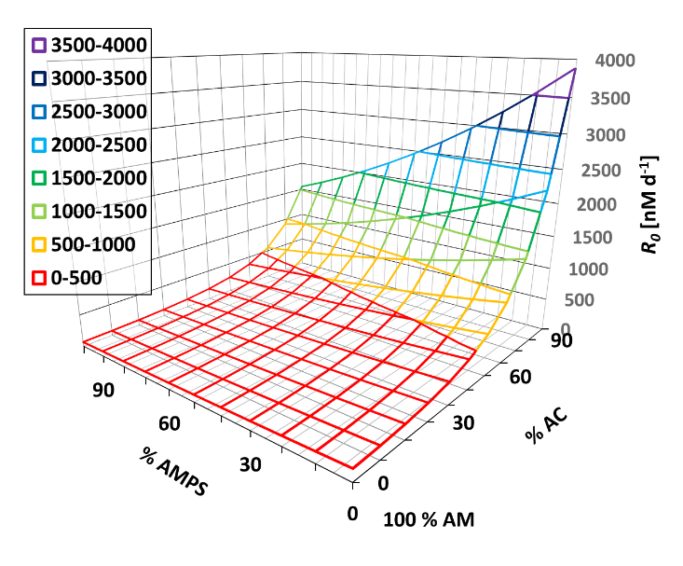b)**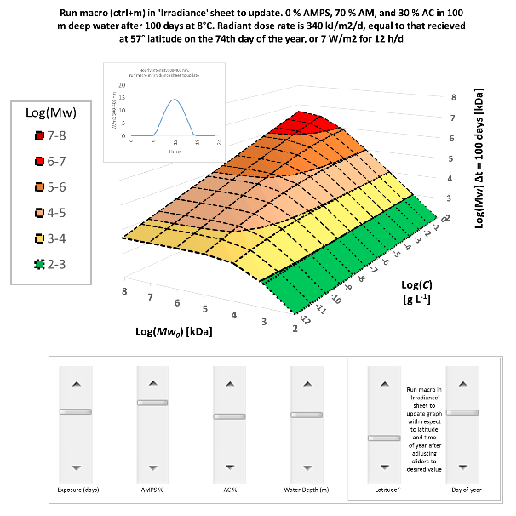

Figure 7 **a)** R0 in PAM as a function of acrylic acid (y) and 2-acrylamido-2-methylpropanesulfonic acid (z) content. Regressions based on the normalized depolymerization rates yield 1. Log(R0(y)) = 2.235+0.002936y + 0.0001065y2 where y is the % mole fraction of AC in PAM. 2. Log(R0(z)) = 2.228-0.003984z where z is the % mole fraction of AMPS in PAM. **b)** Screenshot from the attached interactive depolymerization model.

This decreases to 340 kJ m-2 d-1 when weather is compensated for by adjusting input parameters (i.e. AOD 1.3; Albedo 0.06; Precipitable water 3) to match SolarGIS data (Šúri and Cebecauer, 2010). A factor (*i*)relative to the exposure chamber (i.e. *0.2)* is added to the model (*Eq.12*). It should be noted that at low concentrations, that the time of year, or even time of day, might decide the immediate fate of highly susceptible polymers like PAC. Long-term averages should suffice for slower degrading polymers. Moreover, polymer is bound to distribute in the water column, and depending on depth (*x*) and attenuation of incident light (*μ*), another factor (*k*) is added which is theaverage radiative exposure of the volume relative to the surface given by the integral:

 Eq.11: Average water column light intensity

The reflectivity of the surface should be considered at extreme latitudes as well (Sathyendranath and Platt, 1988; Zafiriou et al., 1984). Almost all incident light (i.e. 99 %) is attenuated within the top 20 meters of most natural waters (Baker and Smith, 1982). In optically transparent water far off the coast, a decadic attenuation of 0.1 m-1 seems appropriate for the near UV range (Booth and Morrow, 1997). Attenuation is normally higher closer to shores and in estuaries due to more particulate and dissolved organic matter (Tedetti and Sempéré, 2006). Ignoring reflectivity and assuming even distribution and regular mixing, *Eq.11* returns *k = 0.04* for 100 m deep water. Corollary, depolymerization rates in the middle of the shallow North Sea should average about 1 % (*i*k)* that of the exposure chamber (Janssen et al., 1999). A not unrealistic volume of polymer (e.g. 54 000 kg, Statoil, 2017) give 1 ng L-1 if discharged, evenly dispersed, and confined to the approximately 54 000 km3 North Sea basin. According to the final model:

 *Eq.12: Complete model*

it should then take HPAM 7030 @ 10 MDa (*Mw0*) about 3615 days for *Mw* to pass the purported biodegradability threshold (i.e. 0.7 kDa). The same would take 242 days with pure PAC, and 13 819 days with PAMPS in the other end of the scale! That ignoring any effects related to the substitution of functional groups, and assuming that *Eq.9* is valid for such low concentrations and that copolymer (and terpolymer) end up biodegradable like the homo-polymeric analogues. For the latter point, it can be argued statistically that the relative frequencies of homopolymeric particles should increase substantially in a heteropolymer below 0.7 kDa (*Mw*). 2.0 polydispersity resulting from random chain scission dictate that half the number of particles is < 0.35 kDa, corresponding to pentamer and below which are proven biodegradable in case of PAC and PAM (McCoy and Madras, 1997; Nyyssölä and Ahlgren, 2019; Wennberg and Petersen, 2017). Photodegraded PAM that most certainly contain some acrylate functional groups from hydrolyzation have also been proven to be biodegradable to some degree (El-Mamouni et al., 2002). In any case, ultimate biodegradability leads to an accelerated decline of residual polymer, effectively marking the end of the polymers life. Although, the possible creation of non-biodegradable by-products still needs to be explored with respect to marine depolymerization. Obviously, the fraction of biodegradable particles increase gradually with depolymerization as the point of cleavage is randomly located along the polymer string. Moreover, even small changes to cut off *Mw* have significant impact on resulting lifetime. For this reason, it is perhaps more meaningful to discuss how fast a moderately low *Mw* is reached. Occurring much sooner, this automatically puts emphasis on transport, fate, and adverse ecological effects mechanisms that will dominate throughout most of the polymers life in the environment (Bolto and Gregory, 2007; Brakstad et al., 2020; Farkas et al., 2020; Guezennec et al., 2014; Shaikh et al., 2017). In that respect, HPAM 7030 @ 10 MDa takes just 253 days to reach 10 kDa and only one tenth of that to reach 100 kDa. Outside of the fringes of the produced water plume however, it will take quite some time before a 1 ng L-1 concentration is reached due to the enormous volumes required to dilute even a small amount of polymer. At 1 μg L-1 instead, it takes 146 days to reach 100 kDa and 20 316 days to reach 0.7 kDa. Likewise, at 1 mg L-1, it takes 793 days to reach 100 kDa and several centuries to reach 0.7 kDa! To assist the reader in understanding these dynamics in scenarios of their liking, corresponding estimates can be easily generated using the interactive version of the model (Supplementary material), from which a screenshot is provided in *fig.7.b.*

# Concluding remarks

Clearly, more advanced models has to be combined with (or developed for) these data. The rate of hydrolyzation in natural environments needs to be identified as a high degree of hydrolysis accelerate depolymerization substantially. Suppliers and operators should also exploit this to design and prioritize use of polymers that have shorter environmental lifetime. On the other hand, molecular weight can be disregarded as to having a real impact on lifetime unless degraded to below the biodegradation threshold, potentially limiting the usefulness of pre-degradation of polymer for this purpose. Moreover, independent from direct sunlight, other sources of radicals exist in the marine environment and has to be explored with respect to marine depolymerization rates (Rose, 2012; Sutherland et al., 2020). Other constituents in produced water and seawater may also bind to and accelerate or retard depolymerization as well. Finally, it seems more data beyond depolymerization rates are needed with respect to other structure property relationships in order to make accurate predictions on adverse ecological effects and transport mechanism.

# Conflict of interest

No conflicts of interest have been identified

# Acknowledgements

The authors acknowledge the Research Council of Norway and the industry partners, ConocoPhillips Skandinavia AS, Aker BP ASA, Eni Norge AS, Total E&P Norge AS, Equinor ASA, Neptune Energy Norge AS, Lundin Norway AS, Halliburton AS, Schlumberger Norge AS, Wintershall Norge AS, and DEA Norge AS, of The National IOR Centre of Norway for support.

# References

Aarthi, T., Shaama, M.S., Madras, G., 2007. Degradation of Water Soluble Polymers under Combined Ultrasonic and Ultraviolet Radiation. Ind. Eng. Chem. Res. 46, 6204–6210. https://doi.org/10.1021/ie070287+

Andersson, M., Wittgren, B., Wahlund, K.-G., 2003. Accuracy in multiangle light scattering measurements for molar mass and radius estimations. Model calculations and experiments. Anal. Chem. 75, 4279–4291.

Baker, K.S., Smith, R.C., 1982. Bio-optical classification and model of natural waters. 21. Limnol. Oceanogr. 27, 500–509. https://doi.org/10.4319/lo.1982.27.3.0500

Barth, H.G., Jr, F.J.C., 1984. A Review of Polymer Shear Degradation in Size-Exclusion Chromatography. J. Liq. Chromatogr. 7, 1717–1738. https://doi.org/10.1080/01483918408068832

Bellenger, V., Ganem, M., Mortaigne, B., Verdu, J., 1995. Lifetime prediction in the hydrolytic ageing of polyesters. Polym. Degrad. Stab. 49, 91–97. https://doi.org/10.1016/0141-3910(95)00049-R

Bird, R.E., Riordan, C., 1986. Simple Solar Spectral Model for Direct and Diffuse Irradiance on Horizontal and Tilted Planes at the Earth’s Surface for Cloudless Atmospheres. J. Clim. Appl. Meteorol. 25, 87–97. https://doi.org/10.1175/1520-0450(1986)025<0087:SSSMFD>2.0.CO;2

Bolto, B., Gregory, J., 2007. Organic polyelectrolytes in water treatment. Water Res. 41, 2301–2324. https://doi.org/10.1016/j.watres.2007.03.012

Booth, C.R., Morrow, J.H., 1997. The Penetration of UV into Natural Waters. Photochem. Photobiol. 65, 254–257. https://doi.org/10.1111/j.1751-1097.1997.tb08552.x

Boysen, B., Henthorne, L., Johnson, H., Turner, B., 2013. New Water-Treatment Technologies Tackle Offshore Produced-Water Challenges in EOR. Oil Gas Facil. 2, 17–23. https://doi.org/10.2118/0613-0017-OGF

Brakstad, O.G., Altin, D., Davies, E.J., Aas, M., Nordtug, T., 2020. Interaction between microalgae, marine snow and anionic polyacrylamide APAM at marine conditions. Sci. Total Environ. 705, 135950. https://doi.org/10.1016/j.scitotenv.2019.135950

Caruso, M.M., Davis, D.A., Shen, Q., Odom, S.A., Sottos, N.R., White, S.R., Moore, J.S., 2009. Mechanically-Induced Chemical Changes in Polymeric Materials. Chem. Rev. 109, 5755–5798. https://doi.org/10.1021/cr9001353

Caulfield, M.J., Qiao, G.G., Solomon, D.H., 2002. Some aspects of the properties and degradation of polyacrylamides. Chem. Rev. 102, 3067–3084.

Dale, A.L., Casman, E.A., Lowry, G.V., Lead, J.R., Viparelli, E., Baalousha, M., 2015. Modeling Nanomaterial Environmental Fate in Aquatic Systems. Environ. Sci. Technol. 49, 2587–2593. https://doi.org/10.1021/es505076w

De Luca, A., Dantas, R.F., Esplugas, S., 2014. Assessment of iron chelates efficiency for photo-Fenton at neutral pH. Water Res. 61, 232–242. https://doi.org/10.1016/j.watres.2014.05.033

El-Mamouni, R., Frigon, J.-C., Hawari, J., Marroni, D., Guiot, S.R., 2002. Combining photolysis and bioprocesses for mineralization of high molecular weight polyacrylamides. Biodegradation 13, 221–227.

Fan, S.-M., 2008. Photochemical and biochemical controls on reactive oxygen and iron speciation in the pelagic surface ocean. Mar. Chem. 109, 152–164. https://doi.org/10.1016/j.marchem.2008.01.005

Farkas, J., Altin, D., Hansen, B.H., Øverjordet, I.B., Nordtug, T., 2020. Acute and long-term effects of anionic polyacrylamide (APAM) on different developmental stages of two marine copepod species. Chemosphere 257, 127259. https://doi.org/10.1016/j.chemosphere.2020.127259

Farré, M., Gajda-Schrantz, K., Kantiani, L., Barceló, D., 2009. Ecotoxicity and analysis of nanomaterials in the aquatic environment. Anal. Bioanal. Chem. 393, 81–95. https://doi.org/10.1007/s00216-008-2458-1

Gaillard, N., Sanders, D.B., Favero, C., 2010. Improved Oil Recovery Using Thermally And Chemically Protected Compositions Based On Co- And Ter-Polymers Containing Acrylamide. Presented at the SPE Improved Oil Recovery Symposium, Society of Petroleum Engineers. https://doi.org/10.2118/129756-MS

Godwin Uranta, K., Rezaei-Gomari, S., Russell, P., Hamad, F., 2018. Studying the Effectiveness of Polyacrylamide (PAM) Application in Hydrocarbon Reservoirs at Different Operational Conditions. Energies 11, 2201. https://doi.org/10.3390/en11092201

Gröllmann, U., Schnabel, W., 1982. Free radical-induced oxidative degradation of polyacrylamide in aqueous solution. Polym. Degrad. Stab. 4, 203–212.

Guezennec, A.G., Michel, C., Bru, K., Touze, S., Desroche, N., Mnif, I., Motelica-Heino, M., 2014. Transfer and degradation of polyacrylamide-based flocculants in hydrosystems: a review. Environ. Sci. Pollut. Res. 22, 6390–6406. https://doi.org/10.1007/s11356-014-3556-6

Howard, A.G., 2010. On the challenge of quantifying man-made nanoparticles in the aquatic environment. J Env. Monit 12, 135–142. https://doi.org/10.1039/B913681A

Huppertsberg, S., Zahn, D., Pauelsen, F., Reemtsma, T., Knepper, T.P., 2020. Making waves: Water-soluble polymers in the aquatic environment: An overlooked class of synthetic polymers? Water Res. 181, 115931. https://doi.org/10.1016/j.watres.2020.115931

Janssen, F., Schrum, C., Backhaus, J.O., 1999. A climatological data set of temperature and salinity for the Baltic Sea and the North Sea. Dtsch. Hydrogr. Z. 51, 5. https://doi.org/10.1007/BF02933676

Joshi, S.J., Abed, R.M.M., 2017. Biodegradation of Polyacrylamide and Its Derivatives. Environ. Process. 4, 463–476. https://doi.org/10.1007/s40710-017-0224-0

Kaczmarek, H., Kamińska, A., Światek, M., Rabek, J.F., 1998. Photo-oxidative degradation of some water-soluble polymers in the presence of accelerating agents. Angew. Makromol. Chem. 261–262, 109–121. https://doi.org/10.1002/(SICI)1522-9505(19981201)261-262:1<109::AID-APMC109>3.0.CO;2-S

Koda, S., Taguchi, K., Futamura, K., 2011. Effects of frequency and a radical scavenger on ultrasonic degradation of water-soluble polymers. Ultrason. Sonochem. 18, 276–281. https://doi.org/10.1016/j.ultsonch.2010.06.007

Lu, M., Wu, X., Wei, X., 2012. Chemical degradation of polyacrylamide by advanced oxidation processes. Environ. Technol. 33, 1021–1028. https://doi.org/10.1080/09593330.2011.606279

Manichand, R.N., Let, M.S., Priscilla, K., Seright, R.S., Quillien, B., Gil, L., 2013. Effective Propagation of HPAM Solutions Through the Tambaredjo Field During a Polymer Flood. Presented at the SPE International Symposium on Oilfield Chemistry, Society of Petroleum Engineers. https://doi.org/10.2118/164121-MS

McCoy, B.J., Madras, G., 1997. Degradation kinetics of polymers in solution: Dynamics of molecular weight distributions. AIChE J. 43, 802–810. https://doi.org/10.1002/aic.690430325

Miller-Chou, B.A., Koenig, J.L., 2003. A review of polymer dissolution. Prog. Polym. Sci. 28, 1223–1270. https://doi.org/10.1016/S0079-6700(03)00045-5

Najamudin, K.E., Halim, N.H., Salleh, I.K., Chai Ching Hsia, I., Yusof, M.Y., Sedaralit, M.F., 2014. Chemical EOR Produced Water Management at Malay Basin Field. Presented at the Offshore Technology Conference-Asia, Offshore Technology Conference. https://doi.org/10.4043/24804-MS

Nomi, S.N., Higaonna, Y., Kasaba, T., Arakaki, T., 2015. Determination of the Bimolecular Rate Constant of Polyacrylamide and Hydroxyl Radicals. Chem. Lett. 44, 220–222. https://doi.org/10.1246/cl.140947

Nyyssölä, A., Ahlgren, J., 2019. Microbial degradation of polyacrylamide and the deamination product polyacrylate. Int. Biodeterior. Biodegrad. 139, 24–33. https://doi.org/10.1016/j.ibiod.2019.02.005

Oil and Gas Authority, 2017. Polymer Enhanced Oil Recovery - Industry lessons learned.

Olje-og energidepartementet, 2018. Prop. 41 S (2018–2019) [WWW Document]. Regjeringen.no. URL https://www.regjeringen.no/no/dokumenter/prop.-41-s-20182019/id2622400/ (accessed 9.22.20).

Podzimek, S., 2019. Molar mass distribution by size exclusion chromatography: Comparison of multi-angle light scattering and universal calibration. J. Appl. Polym. Sci. 136, 47561. https://doi.org/10.1002/app.47561

Podzimek, S., 2014. Truths and myths about the determination of molar mass distribution of synthetic and natural polymers by size exclusion chromatography. J. Appl. Polym. Sci. 131, n/a-n/a. https://doi.org/10.1002/app.40111

Podzimek, S., 2011. Light Scattering, Size Exclusion Chromatography and Asymmetric Flow Field Flow Fractionation: Powerful Tools for the Characterization of Polymers, Proteins and Nanoparticles. John Wiley & Sons.

Prasad, A.K., Mishra, P.C., 2017. Scavenging of superoxide radical anion and hydroxyl radical by urea, thiourea, selenourea and their derivatives without any catalyst: A theoretical study. Chem. Phys. Lett. 684, 197–204. https://doi.org/10.1016/j.cplett.2017.06.040

Ravndal, K.T., Opsahl, E., Bagi, A., Kommedal, R., 2018. Wastewater characterisation by combining size fractionation, chemical composition and biodegradability. Water Res. 131, 151–160. https://doi.org/10.1016/j.watres.2017.12.034

Rose, A., 2012. The Influence of Extracellular Superoxide on Iron Redox Chemistry and Bioavailability to Aquatic Microorganisms. Front. Microbiol. 3. https://doi.org/10.3389/fmicb.2012.00124

Rye, H., Bronner, U., Ditlevsen, M.K., Frost, T.K., Furuholt, E., Kjeilen-Eilertsen, G., Nepstad, R., Page, P.W., Paulsen, J.E., Ramos, R., Ronningen, P., Sorstrom, S.E., 2014. Use of the DREAM Model for Control and Prediction of Concentrations and Environmental Risks Associated with Regular Discharges to Sea: Experiences and Challenges. Presented at the EOSCA Chemistry in the Oillndustry XIV Chemistry: Challenges and Responsibilities, Society of Petroleum Engineers. https://doi.org/10.2118/170763-MS

Sathyendranath, S., Platt, T., 1988. The spectral irradiance field at the surface and in the interior of the ocean: A model for applications in oceanography and remote sensing. J. Geophys. Res. Oceans 93, 9270–9280. https://doi.org/10.1029/JC093iC08p09270

Seright, R., Skjevrak, I., 2015. Effect of Dissolved Iron and Oxygen on Stability of Hydrolyzed Polyacrylamide Polymers. SPE J. 20, 433–441. https://doi.org/10.2118/169030-PA

Shaikh, S.M.R., Nasser, M.S., Hussein, I., Benamor, A., Onaizi, S.A., Qiblawey, H., 2017. Influence of polyelectrolytes and other polymer complexes on the flocculation and rheological behaviors of clay minerals: A comprehensive review. Sep. Purif. Technol. 187, 137–161. https://doi.org/10.1016/j.seppur.2017.06.050

Smalley, P.C., Muggeridge, A.H., Dalland, M., Helvig, O.S., Høgnesen, E.J., Hetland, M., Østhus, A., 2018. Screening for EOR and Estimating Potential Incremental Oil Recovery on the Norwegian Continental Shelf. Presented at the SPE Improved Oil Recovery Conference, Society of Petroleum Engineers. https://doi.org/10.2118/190230-MS

Soponkanaporn, T., Gehr, R., 1988. The Degradation of Polyelectrolytes in the Environment: Insights Provided by Size Exclusion Chromatography Measurements. Water Sci. Technol. 21, 857–868.

Spildo, K., Tweddale, A., Søndenå, E., Guo, Y., Aas, N., Karlsen, T., Verlo, S.B., Olsen, M., 2012. Assessment of Environmental Impact from EOR Chemicals for the Norwegian Continental Shelf. FORCE.org.

Standnes, D.C., Skjevrak, I., 2014. Literature review of implemented polymer field projects. J. Pet. Sci. Eng. 122, 761–775. https://doi.org/10.1016/j.petrol.2014.08.024

Statoil, 2017. Søknad om tillatelse etter forurensningsloven - drift av polymerpilot Johan Sverdrup-feltet - Miljødirektoratet.

Šúri, M., Cebecauer, T., 2010. SolarGIS: New web-based service offering solar radiation data and PV simulation tools for Europe, North Africa and Middle East, in: Proceedings of the International Conference on Solar Heating, Cooling and Buildings EUROSUN.

Sutherland, K.M., Wankel, S.D., Hansel, C.M., 2020. Dark biological superoxide production as a significant flux and sink of marine dissolved oxygen. Proc. Natl. Acad. Sci. 117, 3433–3439. https://doi.org/10.1073/pnas.1912313117

Tedetti, M., Sempéré, R., 2006. Penetration of Ultraviolet Radiation in the Marine Environment. A Review. Photochem. Photobiol. 82, 389. https://doi.org/10.1562/2005-11-09-IR-733

Thomas, A., Gaillard, N., Favero, C., 2012. Some Key Features to Consider When Studying Acrylamide-Based Polymers for Chemical Enhanced Oil Recovery. Oil Gas Sci. Technol. – Rev. D’IFP Energ. Nouv. 67, 887–902. https://doi.org/10.2516/ogst/2012065

Vinu, R., Madras, G., 2008. Photocatalytic Degradation of Poly(Acrylamide-co-acrylic Acid). J. Phys. Chem. B 112, 8928–8935. https://doi.org/10.1021/jp801887t

Wang, B., Chen, Y., Liu, S., Wu, H., Song, H., 2006. Photocatalytical visbreaking of wastewater produced from polymer flooding in oilfields. Colloids Surf. Physicochem. Eng. Asp. 287, 170–174. https://doi.org/10.1016/j.colsurfa.2006.03.051

Wennberg, A.C., Petersen, K., 2017. Biodegradation of selected offshore chemicals (No. M-911). Norwegian Environment Agency.

Wever, D., Picchioni, F., Broekhuis, A., 2011. Polymers for enhanced oil recovery: a paradigm for structure–property relationship in aqueous solution. Prog. Polym. Sci. 36, 1558–1628.

White, D., Drummond, J., Fuqua, C., 2012. The physiology and biochemistry of prokaryotes, 4th ed. ed. Oxford University Press, New York.

Xiong, B., Loss, R.D., Shields, D., Pawlik, T., Hochreiter, R., Zydney, A.L., Kumar, M., 2018. Polyacrylamide degradation and its implications in environmental systems. Npj Clean Water 1, 17. https://doi.org/10.1038/s41545-018-0016-8

Yousif, E., Haddad, R., 2013. Photodegradation and photostabilization of polymers, especially polystyrene: review. SpringerPlus 2. https://doi.org/10.1186/2193-1801-2-398

Zafiriou, O.C., Joussot-Dubien, J., Zepp, R.G., Zika, R.G., 1984. Photochemistry of natural waters. Environ. Sci. Technol. 18, 358A–371A. https://doi.org/10.1021/es00130a001

# Supplementary material

## Chromatograms

### “Structure” experiment

Chromatograms for various polymers at 40 mg/L, before exposure, and after 30 and 60 days of irradiation. All chromatograms have normalized dRI signal curves. The samples have all been concentrated via analyte-enrichment and the injected amount does not reflect experimental polymer concentrations. Specific analysis parameters are presented in the captions. Different column configurations are shown for some high molecular weight samples between chromatograms and molecular weight distribution plots for increasing comparability and accurate representation respectively.

#### PAM

 

Figure 1 PAM 10 kDa before exposure (injected mass 28.74 µg), and after 30 days (injected mass 29.69 µg) and after 60 days (injected mass 41.28 µg), Berry 0th degree fit, detector 1, 2, 3, disabled, Shodex OHpak SB-G, LB-806M, Agilent PL-Aquagel OH Mixed-M @ 1 ml/min.

 

Figure 2 PAM 600 kDa before exposure (left: injected mass 21.37 µg, right: injected mass 22.59 µg with random coil fit, detector 1, 2, disabled, Shodex OHpak LB-G, LB-806M, SB-807 @ 0.15 ml/min), and after 30 days (injected mass 29.36 µg) and 60 days exposure (injected mass 43.50 µg), with random coil fit, all detectors enabled, Shodex OHpak SB-G, LB-806M, Agilent PL-Aquagel OH Mixed-M @ 1 ml/min.

 

Figure 3 PAM 6 MDa before exposure (injected mass 21.66 µg, random coil fit, detector 1, 2, disabled, Shodex OHpak LB-G, LB-806M, SB-807 @ 0.15 ml/min), and after 30 days (injected mass 27.73 µg) and 60 days (injected mass 69.15 µg) with random coil fit, detector 1 disabled, Shodex OHpak SB-G, LB-806M, Agilent PL-Aquagel OH Mixed-M @ 1 ml/min.

#### PAC

 

Figure 4 PAC 2 kDa before exposure (injected mass 19.81 µg), after 30 days (injected mass 31.88 µg), and 60 days (injected mass 21.36 µg), Berry 0th degree fit, detector 1 disabled, Shodex OHpak SB-G, LB-806M, Agilent PL-Aquagel OH Mixed-M @ 1 ml/min.

 

Figure 5 PAC 50 kDa in stock solution (injected mass 134.34 µg) , after 30 days (injected mass 39.35 µg), and 60 days of exposure (injected mass 27.07 µg) with Berry 0th degree fit, detector 1, 2, disabled, Shodex OHpak SB-G, LB-806M, Agilent PL-Aquagel OH Mixed-M @ 1 ml/min.



Figure 6 PAC 450 kDa in stock solution (Left: injected mass 110.02 µg, random coil fit, all detectors enabled, Shodex OHpak SB-G, LB-806M, Agilent PL-Aquagel OH Mixed-M @ 1 ml/min. Right: injected mass 113.86 µg, random coil fit, detector 1 disabled, Shodex OHpak LB-G, LB-806M, SB-807 @ 0.15 ml/min), and after 30 (injected mass 21.53 µg) and 60 days (injected mass 40.19 µg) of exposure, with Berry 0th degree fit, detector 1 disabled, Shodex OHpak SB-G, LB-806M, Agilent PL-Aquagel OH Mixed-M @ 1 ml/min.

#### HPAM



Figure 7 HPAM 9010 200 kDa before exposure (injected mass 30.57 µg, random coil fit, detector 1 disabled, Shodex OHpak SB-G, LB-806M, Agilent PL-Aquagel OH Mixed-M @ 1 ml min/L), after 30 days (injected mass 34.29 µg, Berry 2nd degree fit, all detectors enabled, Shodex OHpak SB-G, LB-806M, Agilent PL-Aquagel OH Mixed-M @ 1 ml min/L), and after 60 days (injected mass 49.64 µg, Berry 1st degree fit, detector 1 disabled, Shodex OHpak SB-G, LB-806M, Agilent PL-Aquagel OH Mixed-M @ 1 ml min/L)

 

Figure 8 HPAM 7030 18 MDa before exposure (injected mass 14.93 µg, Berry 3rd degree fit, detector 1 and 2 disabled, Shodex OHpak LB-G, LB-806M, SB-807 @ 0.15 ml/min), and after 30 days (injected mass 12.85 µg) and 60 days (injected mass 24.22 µg) with random coil fit, detector 1 disabled, Shodex OHpak SB-G, LB-806M, Agilent PL-Aquagel OH Mixed-M @ 1 ml/min.

 

Figure 9 HPAM 6040 10 MDa before exposure (injected mass 12.39 µg, Berry 3rd degree fit, detector 1 and 2 disabled, Shodex OHpak LB-G, LB-806M, SB-807 OH @ 0.15 ml/min), and after 30 days (injected mass 20.69 µg), and 60 days exposure (injected mass 19.62 µg) with random coil fit, detector 1 disabled, Shodex OHpak SB-G, LB-806M, Agilent PL-Aquagel OH Mixed-M @ 1 ml/min.

 

Figure 10 HPAM 3070 200 kDa in stock solution (left: injected mass 70.25 µg right: injected mass 6.98 µg, random coil fit, all detectors enabled, Shodex OHpak LB-G, LB-806M @ 0.5 ml/min), and after 30 days (injected mass 27.45 µg, random coil fit, all detectors enabled, Shodex OHpak SB-G, LB-806M, Agilent PL-Aquagel OH Mixed-M @ 1 ml/min), and 60 days exposure. (injected mass 42.23 µg, Berry 1st degree fit, detector 1, 2, disabled, Shodex OHpak SB-G, LB-806M, Agilent PL-Aquagel OH Mixed-M @ 1 ml/min)

#### PAMPS

 

Figure 11 PAMPS 2 MDa before exposure (left: injected mass 34.72 µg, Berry 2nd degree fit, all detectors enabled, Shodex OHpak SB-G, LB-806M, Agilent PL-Aquagel OH Mixed-M @ 1 ml/min. right: injected mass 33.75 µg, Berry 2nd degree fit, detector 1,2, disabled, Shodex OHpak LB-G, LB-806M, SB-807 OH @ 0.15 ml/min), 30 days (injected mass 17.98 µg), and 60 days (injected mass 42.90 µg) with Berry 2nd degree fit, detector 1 disabled, Shodex OHpak SB-G, LB-806M, Agilent PL-Aquagel OH Mixed-M @ 1 ml/min

### “ROS” experiment

Chromatograms show instrument signal curves overlaid with molecular weight at elution volume (diagonal lines) after 30 days exposure. Instrument signal curves are not normalized. All samples are run with Shodex LB-806 HQ and Agilent PL aquagel-OH mixed-M in series at 0.5 ml/min with Berry 1st degree fits and detector 1 disabled. Injected amount is approximately 100 µL unless otherwise specified. **Left:** dRI = differential refractive index detector signal **Right:** LS = light scatter 90 ° angle detector signal



Figure 12 PAM 6 MDa at 10, 1, 0.1 g/L (10 µL, 50 µL, and 100 µL injected).



Figure 13 PAM 6 MDa 100 mg/L in seawater with Fe(III) 5 mg L-1 alone or in combination with thiourea 50 mg L-1, EDTA 125 mg/L, or hypoxic conditions.



Figure 14 PAM 6 MDa 100 mg/L in seawater with and without nitrogen purge.



Figure 15 PAM 6 MDa 100 mg/L in seawater and deionized water.



Figure 16 PAM 6 MDa at 100 mg/L alone or with thiourea 50 mg/L or with Fe(III) 5 mg/L + EDTA 125 mg/L.

### “Concentration” experiment

Chromatograms for PAM 6 MDa tested at various concentrations after 20 days of exposure. Analysis parameters are the same for all samples except for different injection volumes. Injected volume is 10 µL for 10, 4, and 1 g/L, 25 µL for 0.4 g/L, and 100 µL for lower concentrations. Detector signals curves are normalized. Shodex LB-806M and Agilent PL Aquagel-OH mixed-M in series at 1 mL/min, Berry 1st degree fit with LS detector 1,2,3 disabled.





Figure 17 Detector signal curves (normalized) for PAM 6 MDa at various concentrations **Top Left:** dRI signals curves in dark controls after 20 days at 10, 4, 1, 0.4, 0.1, 0.04, and 0.01 g/L **Top Right:** 90° LS signal curves in dark controls after 20 days at 10, 4, 1, 0.4, 0.1, 0.04, 0.01, 0.004, 0.001 and 0.0004 g/L **Bottom Left:** dRI signals curves in exposed samples after 20 days at 10, 4, 1, 0.4, 0.1, 0.04, and 0.01 g/L. **Bottom Right:** 90° LS signal curves in exposed samples after 20 days at 10, 4, 1, 0.4, 0.1, 0.04, 0.004, and 0.001 g/L.





Figure 18 Unconcentrated and analyte-enriched samples of PAM 6 MDa tested at various concentrations with molar mass overlaid (diagonal lines) after 20 days **Top left:** dRI signal curves for unconcentrated samples tested at 10, 4, 1, 0.4, 0.1, 0.04, and 0.004 g/L (same as above but with molar mass overlaid) **Top right:** 90° LS signal curves for unconcentrated samples tested at 10, 4, 1, 0.4, 0.1, 0.04, and 0.004 g/L (same as above but with molar mass overlaid) **Bottom left:** dRI signal curves for analyte-enriched samples tested at 4, 1, and 0.4 mg/L. 0.1 mg/L gave no useful signal **Bottom right:** 90° LS signal curves for analyte-enriched samples tested at 4, 1, and 0.4 mg/L. 0.1 mg/L gave no useful signal.

 

 

Figure 19 Concentration (bottom of chromatograms) and 90° LS signal curves (top of chromatograms) for unconcentrated samples after 0, 10, and 20 days exposure respectively. Detector signal curves are not normalized. **Top left:** 10 g/L (10 μL) **Top right:** 1 g/L (10 μL) **Bottom left:** 0.1 g/L (100 μL) B**ottom right:** 0.01 g/L (100 μL)

## Alterative model fit

This section contains another method for comparing depolymerization model predictions with actual measurements. HPAM includes PAM and moderately hydrolyzed HPAM.

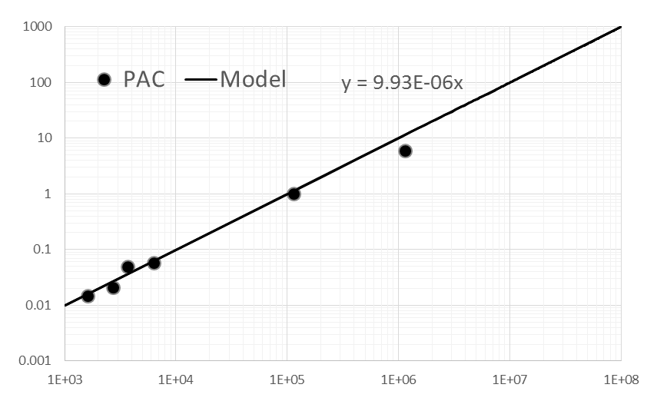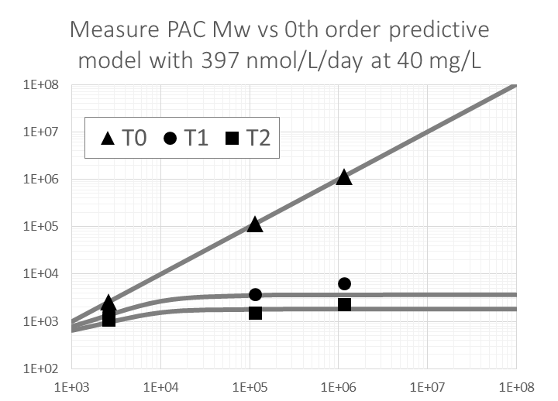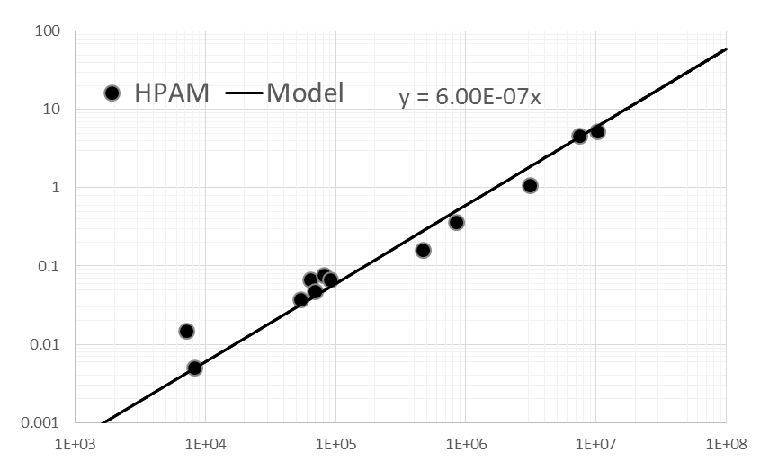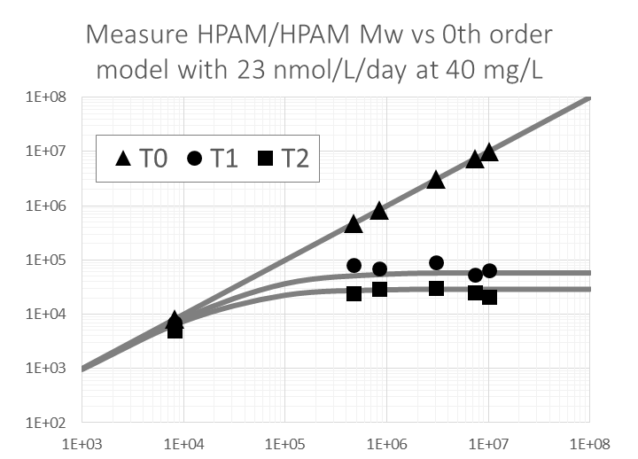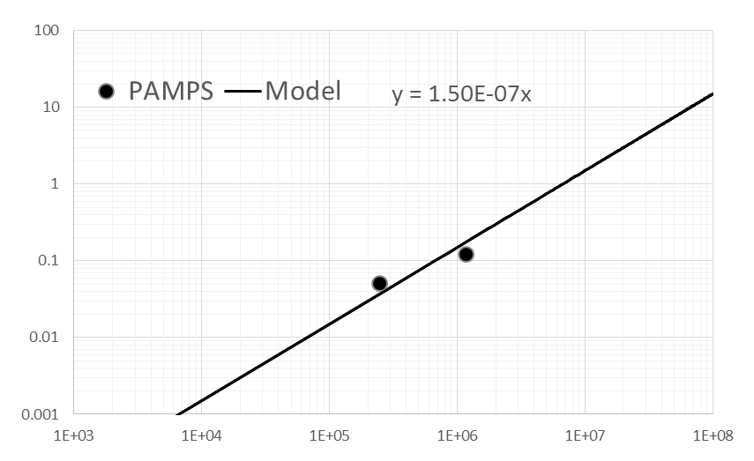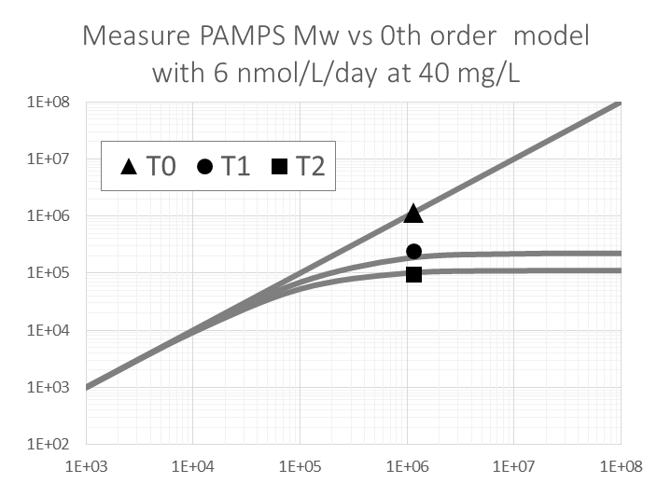

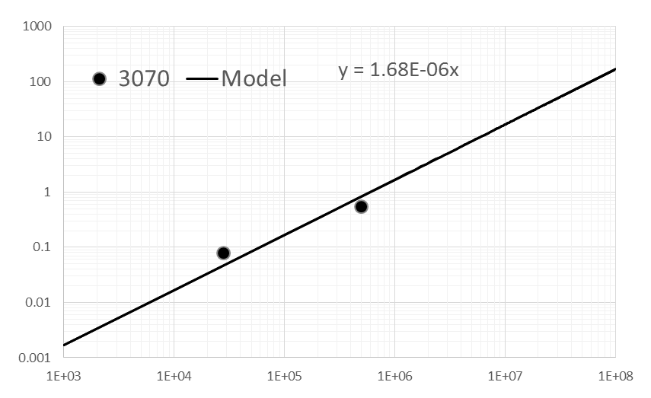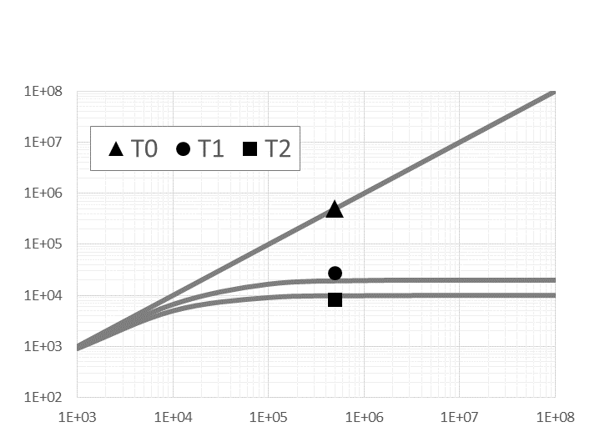

Figure 21: **Left:** Measured number of chains scission events (XHe) per molecule per day (y-axis) for every point of measurement vs initial Mw (x-axis) at 40 mg/L with linear regression. The slope multiplied by concentration yields RC. Departures from regression line appears to be mostly characterization artifacts (i.e. sample concentration, Mw, signal to noise levels, choice of formalism, number of detectors, flow rate etc.) **Right:** Initial molecular weight (x-axis) plotted against measured molecular weight (y-axis) before exposure (T0), and after 30 (T1) and 60 days (T2) using a common value for RC for each type of polymer **Top:** PAC@ RC = 397 ± 72 nM-1 day-1 (± SEM), R2=0.995, n=6 **Top middle:** PAM and HPAM except HPAM 3070 200 kDa @ RC = 24 ± 6.9 nM-1 day-1, R2=0.9816, n=12, 1 outlier ignored **Bottom middle:** PAMPS @ R = 6 ± 1.9 nM-1 day-1, R2=N/A, , n=2 **Bottom:** HPAM 3070 200 kDa @ R = 67 ± 37 nM-1 day-1, R2=N/A, n=2.

 



Figure 22, Transform of the above with respect to Mw where the measurements are inserted as artificial time series based on parallel measurements of polymers with differing initial Mw.

## Uncertainty and replicability, *Mw* vs *Mn*

**a)b)**

**c)d)**

**e)**

Consider the six injections of PAM 6 MDa (**e**). Two exposed for 20 days at 0.1 g/L (top), two dark controls at 10 g/L (middle), and two exposed for 20 days at 10 g/L (bottom). Intra-sample replicability and uncertainties (according to ASTRA 5.0) are normally extremely good for raw chromatograms (**a**-**b**) and when molecular weight distribution is expressed as *Mw* (**c**). *Mn* and corresponding cumulative distribution curves (**d**) show far more variation that would render any derived depolymerization rates much less accurate. Also notice the inadequate separation performance for the polymers that would further compromise *Mn,* but not *Mw*. The relative error introduced to *Mn* corresponds roughly to the shift of the diagonal lines in **a** and **b.** Standards based SEC would without question fail to measure molecular weight moments over such a wide range of concentrations and molecular masses accurately enough for this work to have any value (Podzimek, 2019)**.** The accuracy of *R* would decrease to a point where it would become impossible to distinguish actual depolymerization and measurement error, especially at low *MW* and concentration. The most accurate measurements are obtained using weight average radius alone (*Rw*), but is less useful for predicting environmental fate in this context.

## Exposure chamber temperature

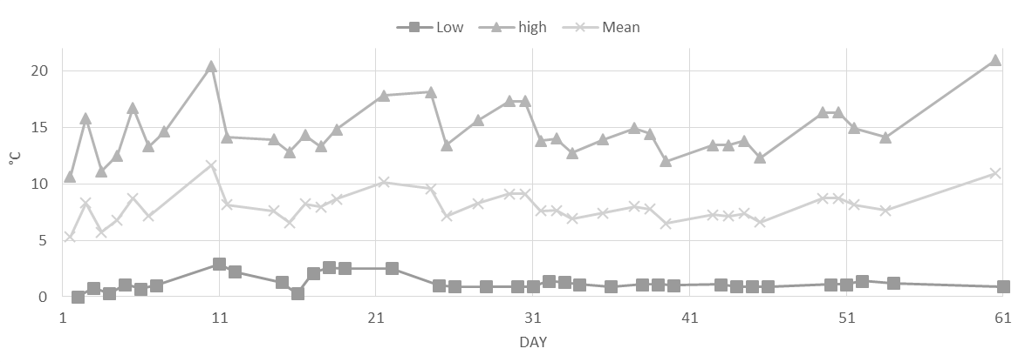

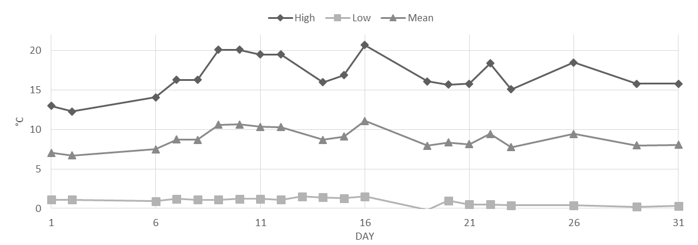

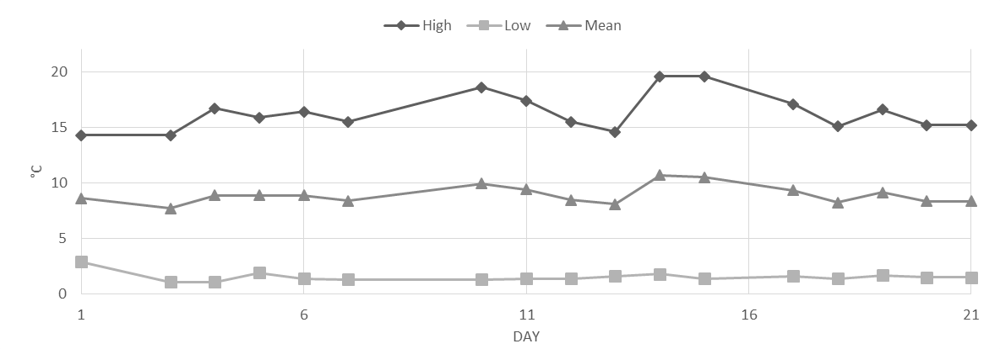

Figure 23 Exposure chamber temperatures with (quasi)daily high/low/mean temperatures (± s.d.), flask temperature is typically 3 °C above chamber temperature during irradiation **Top:** Structure experiment daily averages are, low 1.2 ± 0.6 °C, mean 8.0 ± 1.3 °C , high 14.7 ± 2.3 °C. **Middle:** ROS experiment daily averages are, low 1.2 ± 0.6 °C, mean 8.8 ± 1.2 °C, high 16.8 ± 2.3 °C. **Bottom:** Concentration experiment daily averages are, low 1.5 ± 0.4 °C, mean 8.9 ± 0.8 °C, high 16.3 ± 1.7 °C.